Assignment Title: DA Assignment - 2
Your Name: B. Charvi
Hall ticket no: 22F61A3317
1. Donut Chart (Sales by Customer Type) 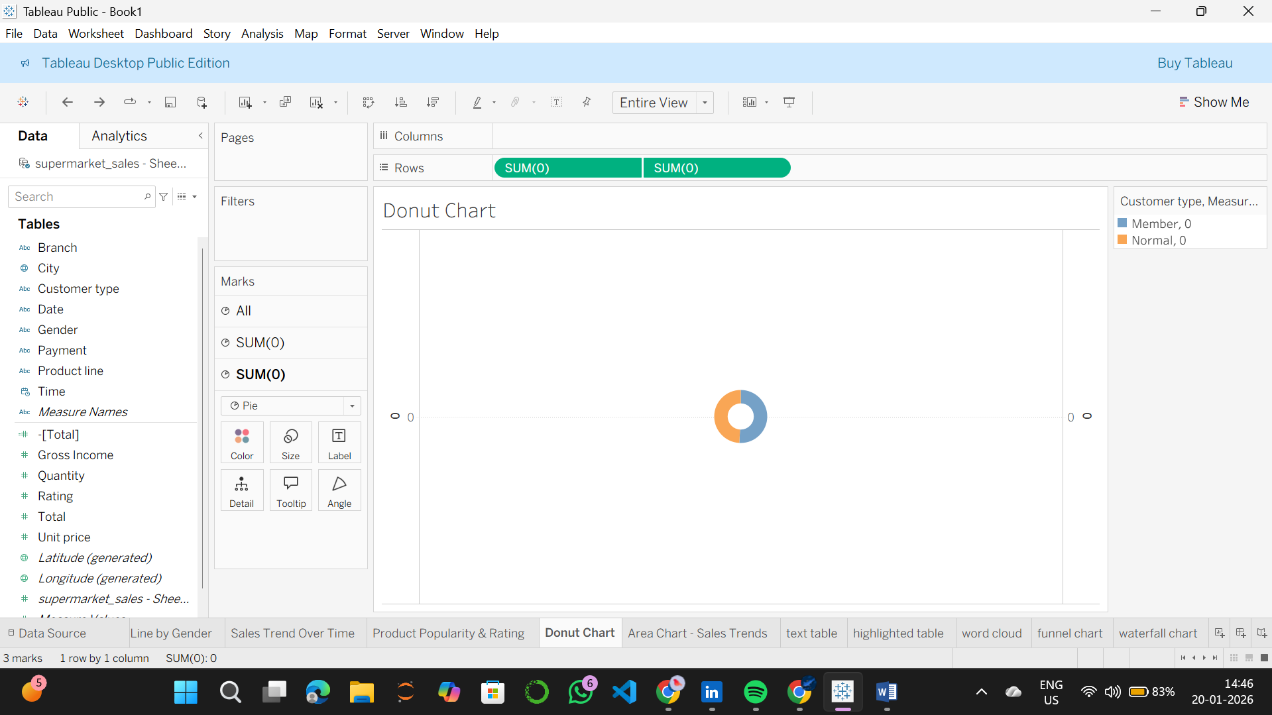Insight: Shows the split between Member and Normal customer revenue.
2. Area Chart (Sales Trends) 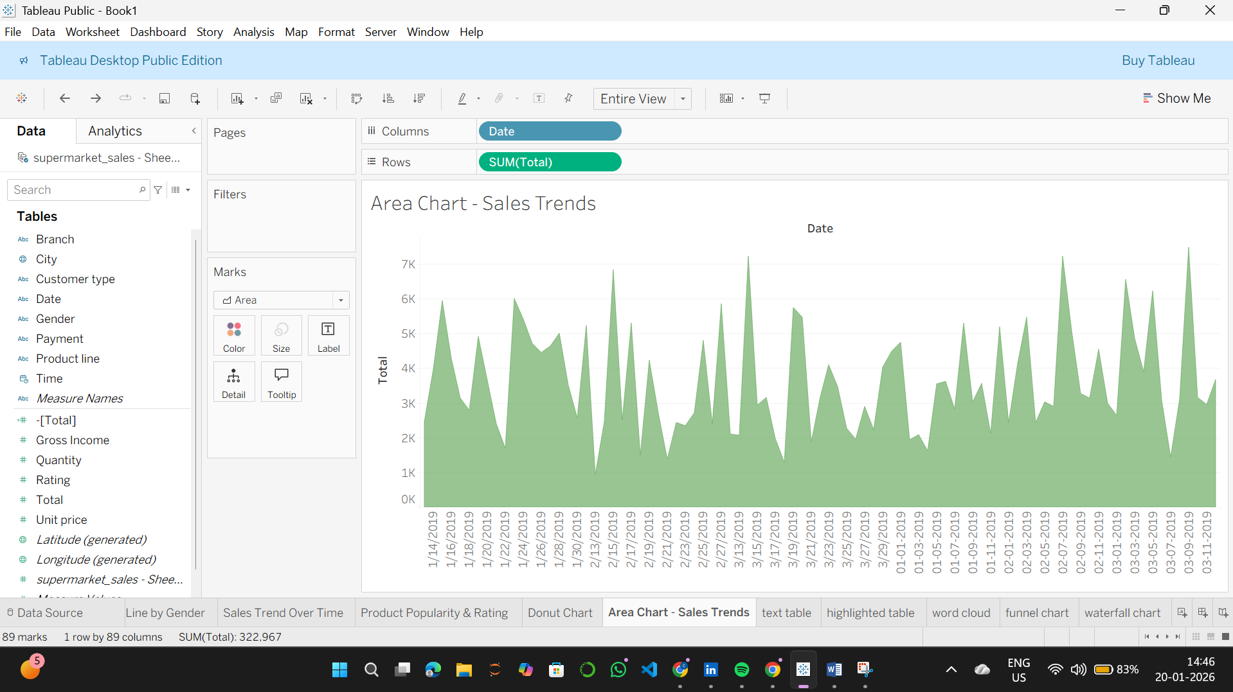 Insight: Highlights the volume of sales over the 3-month period.
3. Text Table (City vs Product) 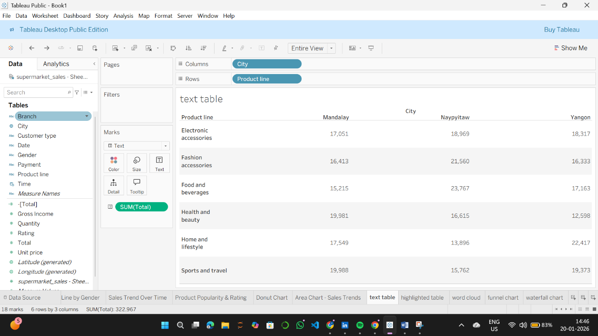Insight: Provides exact sales figures for every category in every city.
4. Highlighted Table (Heatmap) 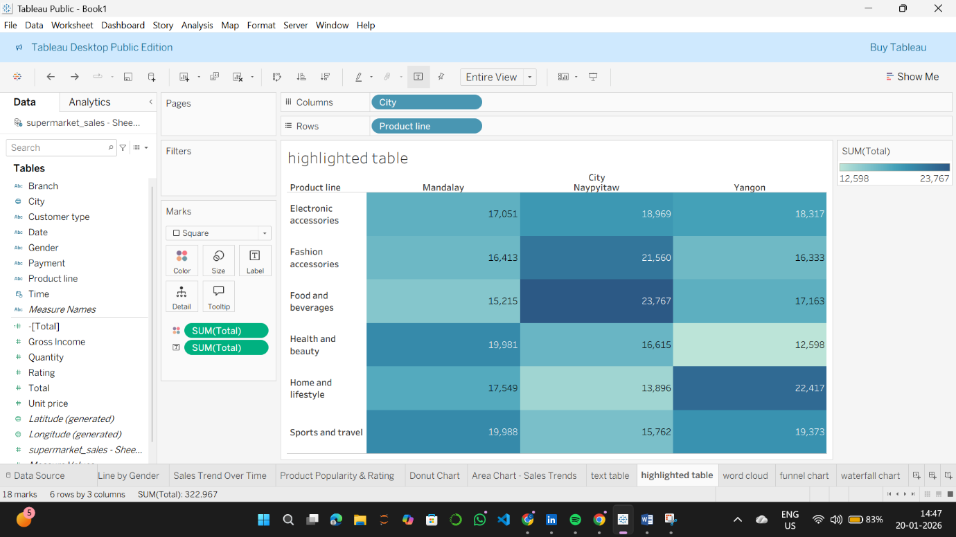Insight: Uses color to quickly identify that Food and Beverages in Naypyitaw is a top-performing segment.
5. Word Cloud (Product Popularity) 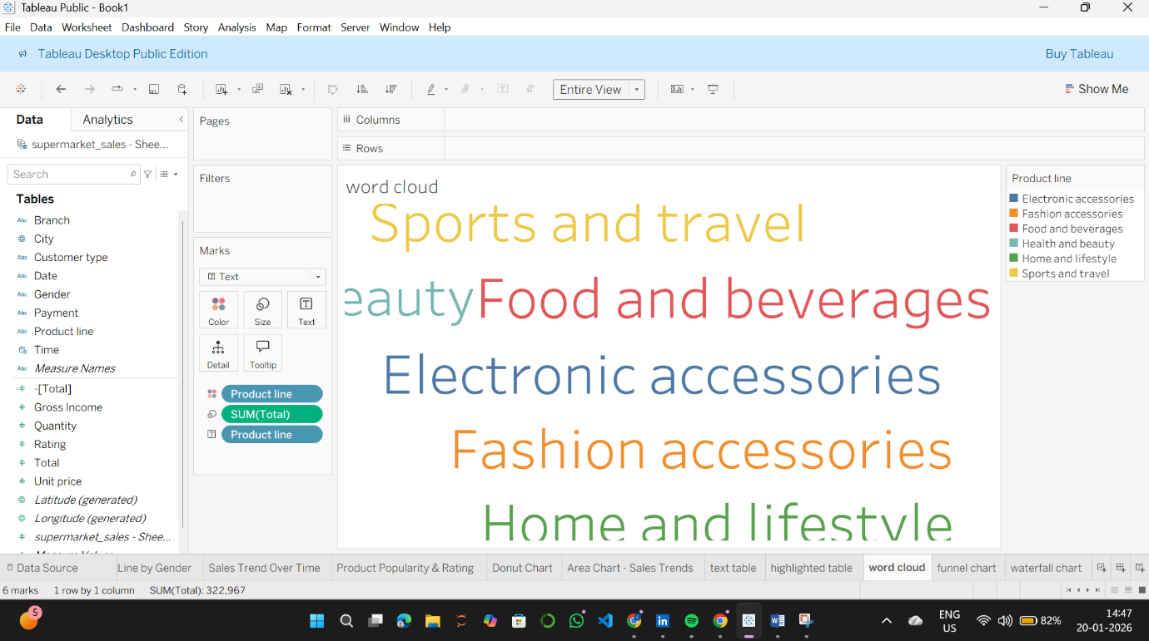Insight: Visually represents category popularity based on quantity sold.
6. Funnel Chart (Payment Distribution) 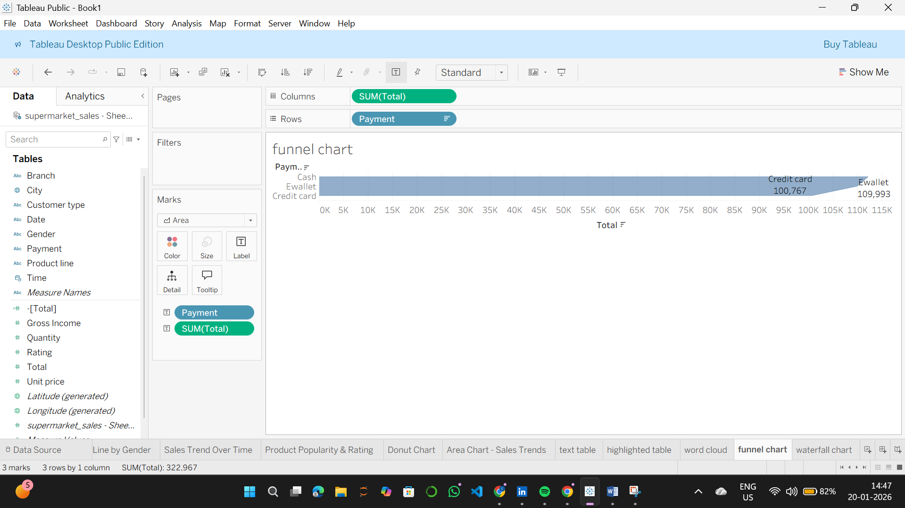Insight: Shows the flow of revenue through different payment methods.
7. Waterfall Chart (Cumulative Revenue) 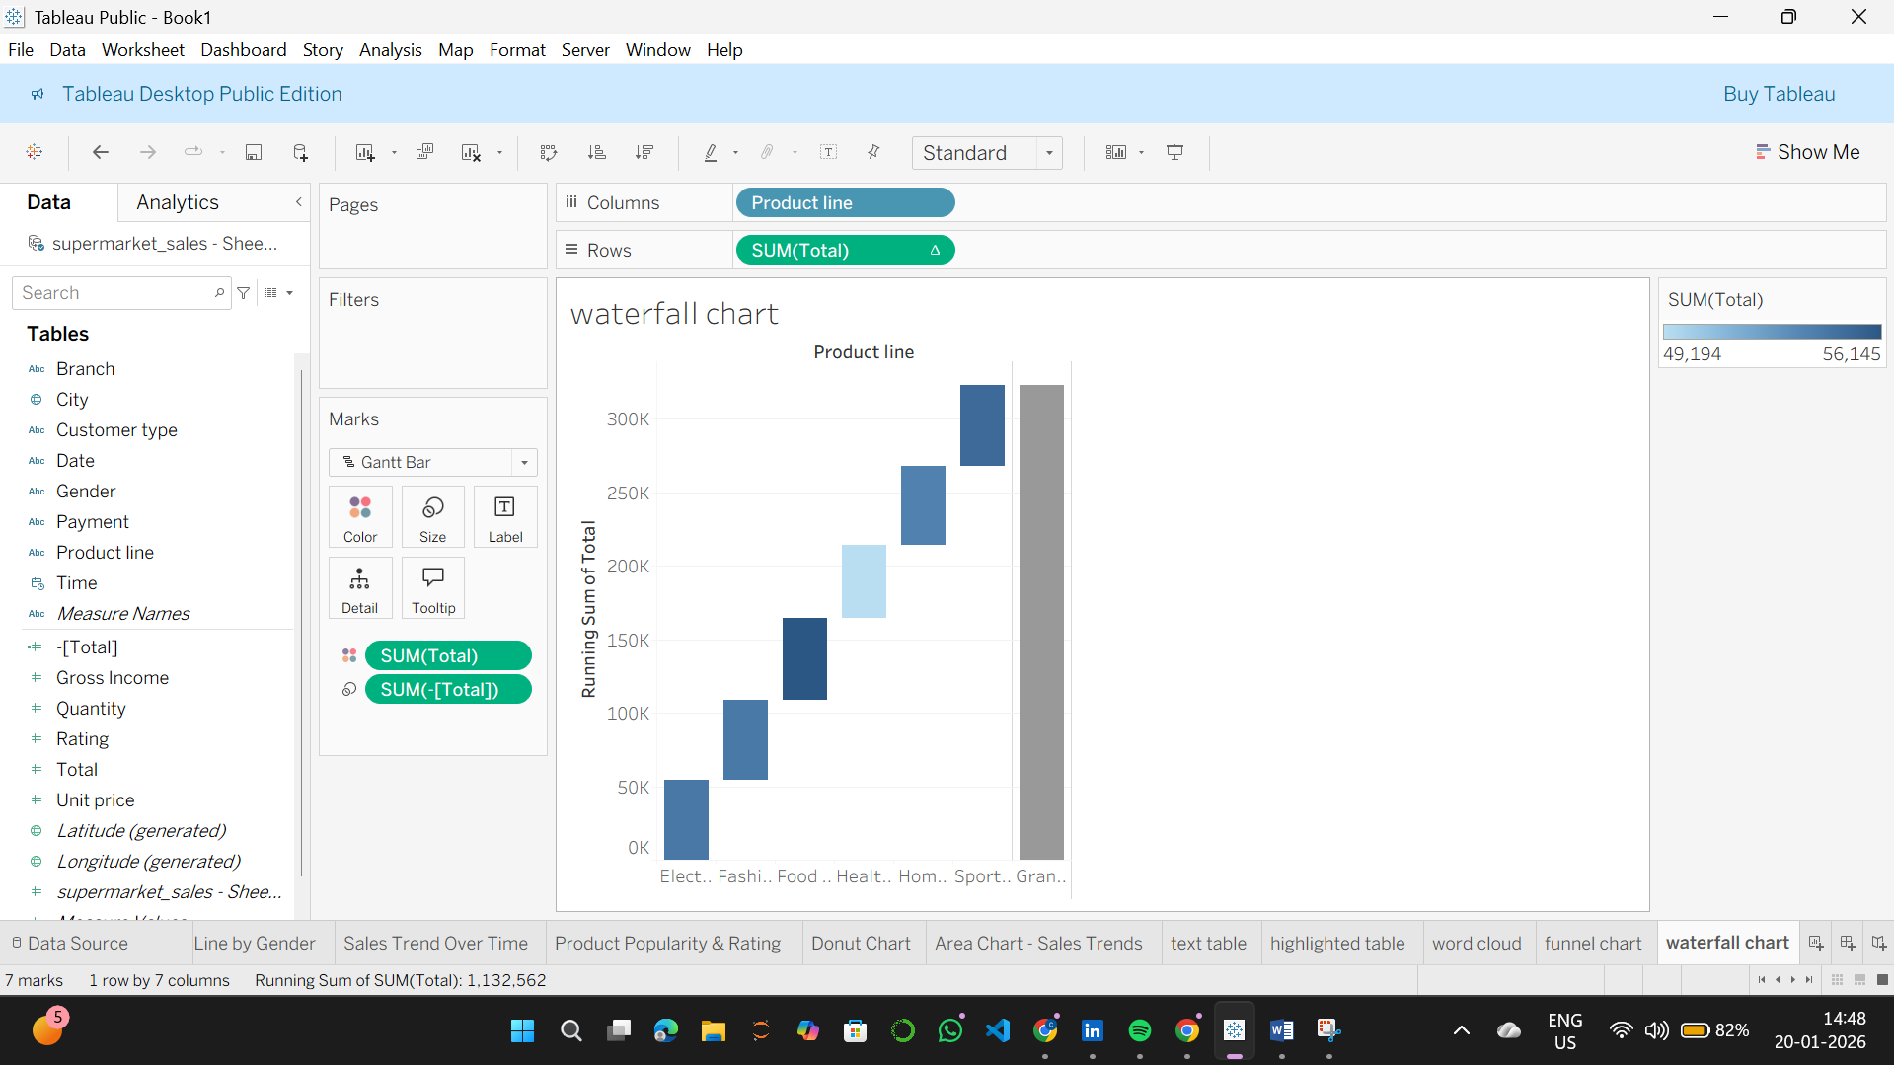Insight: Illustrates how each product line contributes to the final total revenue.

